Pseudocode: Maggie Paul, Caroline Holzapfel

# pseudocode inspiration from Jacquie Silvern

Sketch

* 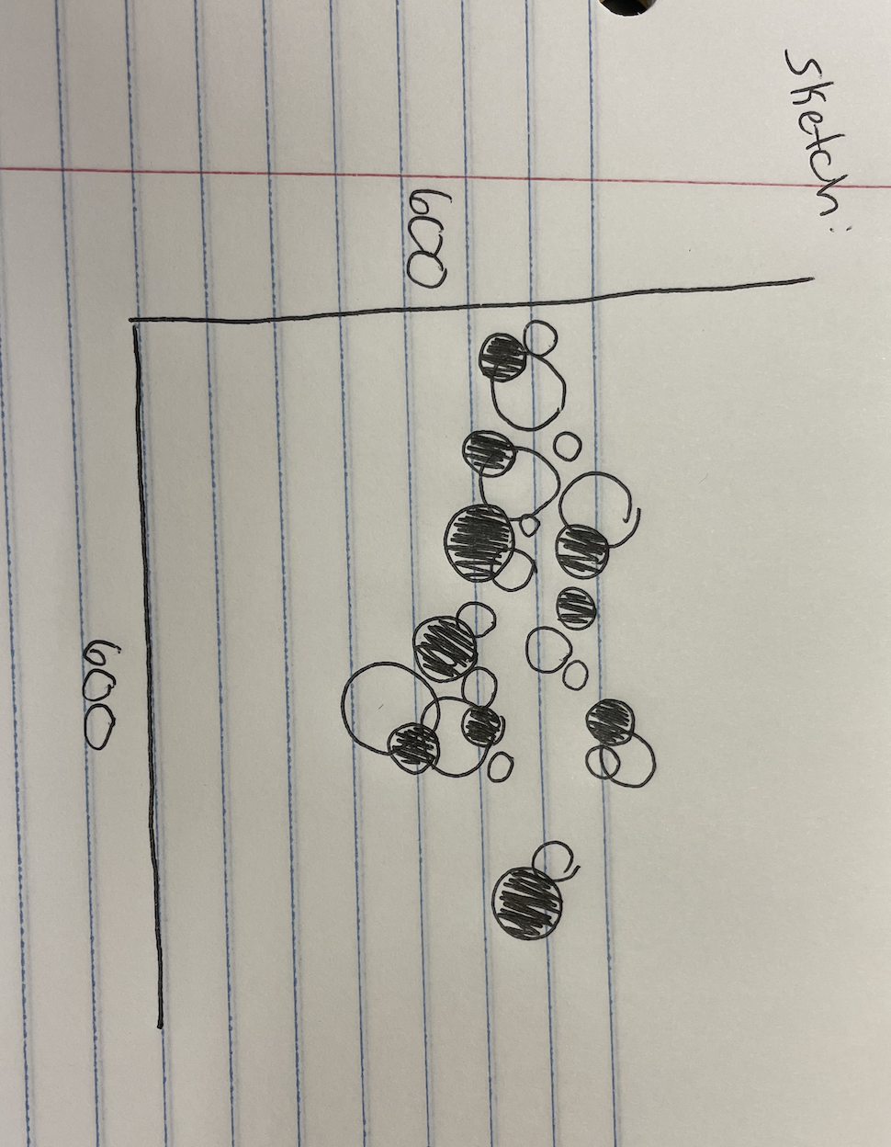

Import Libraries- turtle, random, math

Create panel

* Panel = turtle.Screen()

Panel size

* w= 600
* h= 600

Panel background color

* panel.bgcolor(0,0,0)

Make a FILLED circle

* fillCircle = turtle.Turtle()
* Radius
  + fillCircle.circle(random.randint(lowVal, highVal))
    - lowVal = 10
    - highVal = 80
* Pen Size
  + fillCircle.pensize(random.randint(lowVal, highVal))
    - lowVal = 2
    - highVal = 8
* Color
  + random.choice(circlePalette)
  + fillCirclePalette = [ gray70, LightBlue3, MediumPurple1, linen]
* Fill
  + randint set variable to radius of other variable
  + Outer = randint
  + Inner = randint
* Location
  + fillCircle.goto(random.randint(lowVal, highVal))
    - lowVal = (-300, -300)
    - highVal = (300, 300)

Make a UNFILLED circle

* circle = turtle.Turtle()
* Radius
  + circle.circle(random.randint(lowVal, highVal))
    - lowVal = 10
    - highVal = 80
* Pen Size
  + circle.pensize(random.randint(lowVal, highVal))
    - lowVal = 2
    - highVal = 8
* Color
  + random.choice(circlePalette)
  + circlePalette = [DarkSeaGreen, coral1, CornflowerBlue, LightPink]]
* Location
  + circle.goto(random.randint(lowVal, highVal))
    - lowVal = (-300, -300)
    - highVal = (300, 300)

turtle.down()

for fillCircle in range():

fillCircle.circle(random.randint(10, 80))

fillCircle.forward(inner = random.randint(), outer = random.randint())

fillCircle.right(inc)

turtle.up()

turtle.down()

for circle in range():

circle.circle(random.randint(10, 80)

circle.forward(innerRad)

circle.right(inc)

turtle.up()